Author or Team Members

Team Name

**Project Handbook**

# **Savoy Grill-Bar and Restaurant Website**



**Team Dynamite**

**Team Members**

***Sarbajeet Kumar Mandal***

***Dipendra Chapagain***

***Saurav Shrestha***

***Alisha Chhantyal***

***Ashok KC***

# **Project Start and End Date**

|  |  |
| --- | --- |
| **Project Start Date** | **Project End Date** |
| 05/08/2021 | 06/06/2022 |

# **Revision**

|  |  |  |  |
| --- | --- | --- | --- |
| Version Number | Date approved | Approved by | Description |
| 1.0 | 2021-08-14 | Team Member | Project Vision Document |
| 2.0 | 2021-08-21 | Team Member | Initial Project Plan |
| 3.0 | 2021-9-11 | Team Member | Project Non-functional Requirements & Software and Systems Architecture |

# **Preface**

In this modern scenario, websites have become a fundamental marketing medium for any of the business process. It is now almost impossible to think of a business without having an attractive website.

This project report has been prepared in partial fulfilment of the requirement of our client Mr. Anmol Batish, who wanted us to develop a website for a newly opened restaurant named “Savoy Grill-Bar and Restaurant”.

Before preparing the project report of website development, we organized an online meeting with Mr. Anmol Batish to avail the necessary information. The obtained information was then discussed thoroughly to give the best output.

Hence this report containsthe blend of our knowledge and requirement of the client.

____________________

Sarbajeet Kumar Mandal

DipendraChapagain

Saurav Shrestha

Alisha Chhantyal

Ashok KC

Contents

**Savoy Grill-Bar and Restaurant Website** 0

**Project Start and End Date** 1

**Revision** 1

**Preface** 2

Table of Figures 4

**Vision Statement** 4

**1** **Introduction** 4

**1.1** **Project Overview** 4

**1.2** **Project Scope** 5

**1.3** **Project Deliverables** 6

**1.4** **Evolution of the Handbook** 6

**1.5** **Definitions and Acronyms** 6

**2** **Organization** 7

**2.1 Process Model** 7

**2.2 Organizational Structure** 8

**2.3 Organizational Boundaries and Interfaces** 9

**2.4 Project Responsibilities** 10

**3** **Managerial Process** 11

**3.1 Management Objectives and Priorities** 11

**3.2 Assumptions, Dependencies andConstraints.** 11

**4** **Technical Process** 11

**4.1 Methods, Tools, and Techniques** 11

**4.1** **Software Documentation** 12

**5** **High level Project Plan** 12

**6** **Non-functional Requirements** 13

**6.1** **Platform** 13

**6.2** **Communication** 13

**6.3** **Performance** 13

**6.4** **Security and Privacy** 14

**6.5** **Audience, Usability and Accessibility** 14

**6.6** **Reliability** 14

**6.7** **Modifiability** 15

**6.8** **Legal** 15

**6.9** **Standards** 15

**7** **Software and Systems Architecture** 15

**7.1** **Architecture objectives** 15

**7.2** **High level architecture** 16

**7.3** **System Context** 17

**7.4** **User Interface/ Interaction Design** 18

**Prototype** 18

**Use case diagram** 21

**7.5** **Data model and software design** 22

**7.6** **Assumptions** 22

**7.7** **External Dependencies** 22

Table of Figures

**Figure 1: Process Model 7**

**Figure 2: Organizational Structure 9**

**Figure 3: System Architecture 15**

**Figure 4: Three Tier Architecture 16**

**Figure 5:System Context 17**

**Figure 6:Prototype Homepage 18**

**Figure 7:Prototype Navigational Menus 18**

**Figure 8:Prototype About Us Section 19**

**Figure 9:Prototype Footer 19**

**Figure 10: Initial Use Case Diagram 20**

**Figure 11:ER Diagram 21**

# **Vision Statement**

The ultimate goal of our project isto build a website for Savoy Grill-Bar and Restaurant that will help them to run their business smoothly in this digital world by increasing the interaction with existing and potential customers. We believe that the website of the restaurant will impress a lot of patrons just as much as its food*.*

# **Introduction**

## **Project Overview**

Established in 2020, Savoy Grill – Bar and Restaurant is a new family owned business that offers lunch and dinner to the customer. Being a new restaurant of this modern time it has a lot of challenges to stand with, among which a need of website that will help the owner and management of the restaurant to run their business in this digital world is one. A good website can help the business to run smoothly by increasing the interaction with customers and other stakeholders. A lack of website means missing out on a massive audience. Online visibility is huge for restaurant and can ultimately determine whether customers will come to the restaurant or not.

The project report herby contains the detail description of the website development process for our client Savoy Grill-Bar and Restaurant to meet their requirement.

## **Project Scope**

We will be responsible for developing a website by ensuring all the features are tested and functional before the final product launch. There would be 2 user groups for this website, i.e., Customer and Staffs (admins).

The required functionalities for customer are as follow, where customer will be able to:

* + Sign Up/Login/Log out.
  + View menu items.
  + See location and opening times of the restaurant.
  + Book Table
  + Book Events
  + Leave a review.
  + Become members and gain points on visit.
* Staff (Admins ) will be able to:
  + Sign Up/Login/Log out.
  + Add/Edit/Delete menu items
  + Check Table bookings and allocate tables.
  + Check Event bookings and contact customer.
  + Update opening times.
  + Update message on the front page (e.g. update on covid restrictions)
  + Reply to customer feedback.
  + Update personal availability – will be used by managers to create rosters

## **Project Deliverables**

After the completion of this project , we will be able to deliver the following:,

* A complete website with all features fully developed and tested.
* A complete User manual
* All the technical documents used in this project.
* Data like text, files, images, graphs…. used in this project.

## **Evolution of the Handbook**

The handbook will be updated by the project manager based on the outcome of the meeting with the client and team members. The meeting to the client is scheduled to happen in a fortnightly basis on Thursday at 6:30 pm, while the meeting among the team members is scheduled to happen every Saturday at 4:00 pm, until the end of the project.

After a concrete decision is made in a meeting with the client, the change then will be updated in the handbook and everyone will be notified of the change via email. The following are the potential phase of evolution of the handbook.

Phase 1: Release of Project Vision document

Phase 2: Release of Initial project plan

Phase 3: Release of Compete Project Handbook

Phase 4: Release of Updated Project Handbook

## **Definitions and Acronyms**

|  |  |
| --- | --- |
| **Term** | **Definition** |
| Sign Up | Opening of new account |
| Login | An act of getting access to a computer or specific system |
| logout | An act of getting out from the system. |
| Client | A person or organization using a services of a lawyer or other professional person or company. |
| Allocate | Resources for specific purpose. |
| CONTENT MANAGEMENT SYSTEM (CMS) | The CMS allows you to actively manage your website’s content behind-the-scenes. You can change the copy on a product page, answer blog comments, add keywords to content, and much, much more. |
| CASCADING STYLE SHEETS (CSS) | While HTML defines the structure of the content on a web page, CSS defines the style. Using CSS, developers can change the design and layout of your website |
| GRAPHICS INTERCHANGE FORMAT (GIF) | A GIF file creates the effect of animation by combining multiple images into one file. These images can then be played in a loop, thus creating an animation. |
| HYPERTEXT MARKUP LANGUAGE (HTML) | This programming language is the building block of websites. |
| KEY PERFORMANCE INDICATORS (KPI) | KPIs are the benchmarks that tell you if your website is doing its job and doing it well. Different companies will have different KPIs |
| PORTABLE NETWORK GRAPHICS (PNG) | PNG files are similar to GIF files and JPEG files. They offer high-quality imagery for the graphics found on your website. |
| USER EXPERIENCE (UX) | UX in website design is the groundbreaking idea that visitors to your website can actually enjoy using your site and be able to use it to its full potential. |
| User Manual | A user guide |

# **Organization**

## **2.1 Process Model**

While doing a project, we require various methods of representation of the existing and planned resources to provide an excellent overview of what is happening in the project. A project can be done using various ways but in this project we are planning to use SCRUM methodology. SCRUM is an agile project management methodology that involves a small team which is led by a SCRUM master and the works are done in short cycles also called sprints. The sprints gives the idea of the required tasks that is to be completed in each stages. Once one of the sprints is completed, it can be delivered even if other sprints works are being done. Scrum methodologies consists 6 stages of development to completed the project.

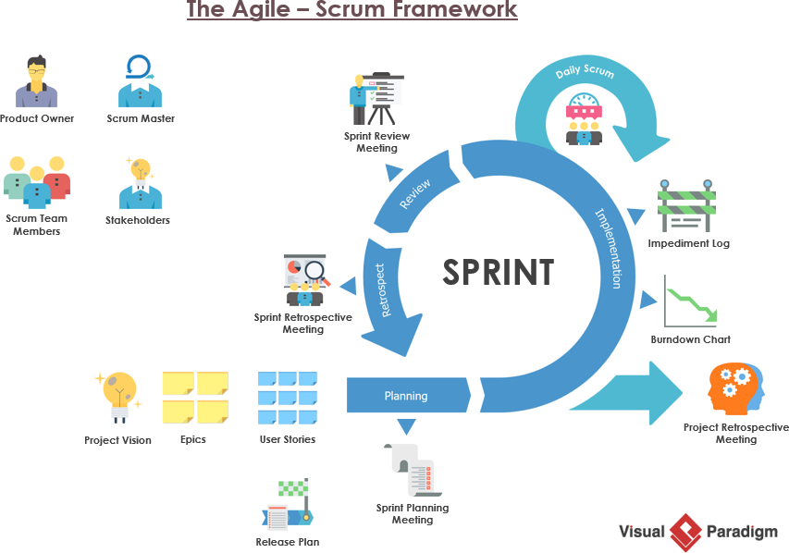

Figure 1: Process Model

Source: <https://www.ossia-belgium.com/about-agile-organisation/>

The six stages that are consisted in the SCRUM methodologies to complete the project are as listed below:

* Organise the backlog: this stage is also called as backlog grooming. A product owner has their responsibility in this stage as they have the vision of the project and the idea of the backlog. A SCRUM master is identified, and the stakeholders are made to be known to the project master.
* Sprint planning: A product backlog that was created in the previous step are worked in this iteration which is known as sprint. The team members organise a meeting frequently so that a good idea is developed to meet the desired goal of the sprint. After all the meetings and designation, all the team members need to be insightful of what must be delivered in the given sprint.
* Sprints: The SCRUM team works together to finish the initial phase. A sprint usually takes two weeks to be completed depending upon the functionality/non-functionality of the project. In order to complete a sprint, a normal idea of how much time it takes is formed and it has to remain consistent thorough out the project.
* Stand up: A brief meeting is organised every now and then in order to discuss the progress of the sprint. Stand up is done during the time of the project working hours and the team members discuss the progress like what they did, what has to be done and what difficulties they faced during developing the sprint and the meeting usually lasts for 15 minutes
* Sprint review: when the sprint is completed, the team reviews the increment, and the final work is shown to the stakeholder and the team to provide the feedback. The project owner has his final say on whether to go with the sprint or not. It remains the responsibility of the project owner to provide the feedback and to ask the team member whether to add or remove the sprint if required.
* Sprint retrospective: in this final step, all the team members discuss and document all the work that they did during working on the sprint, like what worked and what not worked while developing a sprint. This helps all the team members to find the space that can be improved for upcoming project so that they can save their time and be more effective.

## **2.2 Organizational Structure**

A team consist of various member who are given their specific roles according to their capabilities so that while doing a project, it is completed in each time frame with good result. In this project, the project owner sponsors the project, and the project manager is responsible to manage the entire project. A designated SCRUM master is responsible of managing the different functionalities to develop a sprint and then dividing the task between the team members. The following chart shows the different responsibilities that has been given to the team member so that the project can be ran within the given time frame.

Figure 2: Organizational Structure

The project manager takes the responsibility of dividing the number of sprints to the team members based on their skills and the responsibilities is provided to the team members to complete their part of sprints in the given time.

Change in roles: The team members has the privilege to change the roles that are given to them if they think they cannot do the task that has been provided to them or if they can do better in another roles, they can always come up and discuss about it. The project manager can then change the roles according to capacity.

## **2.3 Organizational Boundaries and Interfaces**

The relationship between the client and the project team members plays an important role in any project. This defines the success ratio or the rate of the work that are to be done. A good relationship should be developed between the client and the team members to make the project proper success and the in order to maintain a healthy relationship between the stakeholders and the team members, a proper communication that is timely based should be organised. In this project, the stakeholders are project owner, project manager, project sponsors and all other team members.

A team members develop some of the functions in each sprint. Once all the sprints are developed it is shown to the client with the help of the project manager. The project manager will take the feedback from the client in each sprint and later makes the changes that are necessary for the project. Furthermore, the project is checked again for more changes if required by the project manager and the feedback from the client is taken into consideration before changing anything or handing over the project.

Some of the works that are done in each sprints are like:

In sprint 1 we design a home page including the function and the logo of the company

In sprint 2 we design a menu items that are to be shown to the customers.

In sprint 3 we work on the signup page where both the customer and the staff needs their credentials to sign in.

Likewise we carry other works in other sprints.

## **2.4 Project Responsibilities**

Our team for this project is composed of 5 members. The team information with their respective role is cited below.

|  |  |
| --- | --- |
| Name | Role |
| Sarbajeet Kumar Mandal | Project Manager |
| DipendraChapagain | Project Assistant |
| Saurav Shrestha | Technical Expert |
| Alisha Chhantyal | Researcher |
| Ashok KC | Programmer |

# **Managerial Process**

## **3.1 Management Objectives and Priorities**

The main managerial philosophy is to complete the project with all the requirement on time. Our aim is to deliver the project to our client maintaining with all the quality and adding good performance. This is done by the help of team contribution and their effort.

While doing the project there can occur conflict among team members or with client , This can be handle by knowing the details reason of the cause of conflict, and breaking down each problems and solving respectively.

## **3.2 Assumptions, Dependencies andConstraints.**

Assumptions, Dependencies and constraints are made under the supervision of all project member, project manager and stakeholders,

* The assumption of the project is to deliver on time.
* There should be equal contribution of each members in the development of the project.
* The project is fully supported by all the stakeholders, sponsored and all team members involved in the project.
* Each project part will convey an understanding report of the work done and update in the handbook.
* At the point when the project is finished it will be additionally tried again ensuring that the website is working faultlessly.

This project has some constraints as well. Those constraints are mainly business and technical. Project timeline, limited resources, maintain project scope falls under business constraint. The technical constrains include project compatibility and limited IT technicians.

# **Technical Process**

## **4.1 Methods, Tools, and Techniques**

* In the development of the project Scrum project method is used.
* For the project development HTML, CSS, JavaScript, MYSQL and PHP has been used where as for meeting with the client and team Zoom has been used.
* As scrum methods has been used in this project management so, the main techniques is breaking down the project in each sprint .
* Zoom, Face-book Messenger and Whatsapp has been used for the communication purpose among the team. GIT hub is mainly used for the project sharing.

## **Software Documentation**

The documentation either explains how the software operates or how to use it, or may mean different things to people in different roles.

* Requirements: Any operating system, Any browser ,Any platform.
* Technical: algorithm ,design
* End-user: Customer, Client and staff .

There are two type of software documentation for this project. The first one is user document and second one is technical document. The user documentation is for the user of the project so that they can know how to use the website, what can be done through the website and is like the user manual which contains all the information of the website. The technical document is for the programmers and developers so that they can build the website as described by the  
client and all the technical part related to the project for the successful completion of the project.

Plan for technical documentation: For the technical documentation, we will require to draw different UML diagrams like ER Diagram, Use Case Diagram, and sequence diagram. So, these diagrams are created either by Enterprise Architecture or Lucid chart. These are the information that are provided to the developers.

Plan for user documentation: User documentation is for the user to guide how to operate the website and their functions. The user documentation comprises of a user manual, help report and FAQs on the web.

# **High level Project Plan**

For the high level of project plan, we had meetings with team members and clientWe divide each task into 5 different sprints as per scrum framework.

In sprint 1 : planning of main page, which include designing of index page.

We mainly focus on designing the main page where we include all the function and menu, we use html to make backbone of website and css to design.

In sprint 2: working on 1st main function menu.

Menu is the main function where we include all the food items and their short description . we design menu is such a way that it can be edit by admin.

In sprint 3: working on 2nd main function on Booking

Booking is also one of the major function of the website, In which customers can book table so that they don’t have to wait when they arrived.

In sprint 4: working on 3rd main function on login portal.

Login is secondary function ,it can be done by both customers and admin, once customers login they can book table and do the other main things where they can help them self to access the restaurant.

In sprint 5: working on last main function on updating menu and admin panel.

Once Admin login , they can update menu, update rosters, manage tables and booking.

We divided each task to every team member as per the sprint , and also we are team of five.

For file sharing in project we have use collaboration tool as GIT HUB

Link: <https://github.com/sarbajeetmadnal4/Savoy-Grill>

# **Non-functional Requirements**

Non-functional requirements define the system attributes such as security, reliability, performance, maintainability, scalability, etc. A non-functional requirement of the website is used to judge the operation of a website rather than specific behaviours.

In our website too there are various non-functional requirements that helps us to judge the operation of the website. Some of the non-functional requirements of the website of ours can be listed as below:

## **Platform**

The website that we have been developing can be run on a normal PC that has windows as an operating system. It does not require a fast-processing computer and can be run in any computer with core processor higher or equal to i5. The website is designed with having the focus on the user who uses PC from where they can explore our website by using any web browser. Java and allied web technologies were used for advancement of the website

## **Communication**

The communication aspect of the website is based on the bootstrap framework. During the communication process , the website will transfer the Bootstrap framework to load the existing CSS and JavaScript. The browser transmits the bootstrap server to get the data needed on the website. For getting the data accessible on the website, it should be connected with the database and for that it requires to communicate with MySQL for getting the data

## **Performance**

The performance of the website is one of the best things to experience. The features that are available in the website can be accessed in a few seconds. Although the performance may differ from each other depending on the internet speed and sometimes it happens due to loss of network. The website is active and collects all the data into the server instead of device. In order to run the website high arrangement is not required. It can be done by using normal web browsing applications Every page load within 2 seconds time, given the internet and the device of the user is up to the standards that has been recommended by us.

## **Security and Privacy**

In this modern world, security and privacy has been focus of any website or any browser that stores the user information. Since, internet theft has been growing a lot, providing the security to the user database has been out main priority. The information stored by the user are given option whether to save it or not like storing the credit card details, saving their name and address for making the booking easier in future, etc. If the user wants to store their information, all the information along with the password is encrypted by the system. User is advised to change the password to their account once in a every three month. The booking confirmation emails consists of user details so these emails are encrypted and only the person who receives it can see the information contained in it.

The password and the credit card information which are kept on the data base can be encoded using the PHP crypt() function and for the transaction process TLS layer is used so that the proceedings happening will be every time excavated and secured. Authentication is necessary to run the system by the user.

## **Audience, Usability and Accessibility**

The website is mainly focused to the people who are enthusiastic of seeing out the menu or the location of the restaurant before trying out the food and spending their leisure time with their loved ones having the food they love. In today’s world people are busy with their lives and want to make the time they have utilised at its best. So, our website offers the customer to make a booking prior to visiting the restaurant so they do not have to wait for any tables.

Website is easier to use and anyone who can use the internet can easily use browse through our website. It is easily accessible, and one can enter their details and instantly book the table and the date to spend their time with their loved ones.

## **Reliability**

Our website runs without any interference or any hindrances in the devices as we have recommended. We have successfully used all the features without any lagging. But also our experts teams are always on their way to make up for any fault logging in any foreseen circumstances.

## **Modifiability**

The website is often modified in every 6 months. All the users are given a message when they login to their account regarding the modifications that is happening to the website and the update, or the modifications generally does not take more than 6 hours and are done mostly during the night-time so that on the next day it is ready for the customer who wants to access the system.

## **Legal**

**Copyright concerns**: All of the photos used on the site are secured through legitimate channels and there is no copyright violation.

**Trademarks**: The logo used in the website recognizes the trademark of Savoy Grill Restaurant. This trademark gives the owner the selective rights to execute or sell the secured thing for the administrations or products which is registered.

## **Standards**

All the documents delivered will adhere to the IEEE standards for software engineering. Some of the standards are as follows ;

* HTML standards (e.g. HTML 5.0).
* CSS coding standards
* JAVA coding standards
* Australian Standard AS4071-1992(R2014)- Software project management plans.

# **Software and Systems Architecture**

## **Architecture objectives**

Image result for architecture objectives can be explained as a bunch of essential prerequisites and confident results, subject to practical imperatives. Plan goals and utilitarian necessities are what the plan ought to make progress toward. It is ideal to characterize the ideal and OK qualities. The main goal of developing the system architecture is to develop a website for restaurant which can be opened in any browser, and which is secure for the users as well. It allows users to sign up from any browser they prefer whereas their personal information/data are encrypted.

## **High level architecture**

A High-Level Architecture (HLA) is a group of related principles that together portray a brought together methodology and normal design to developing interoperable re-enactment frameworks. The Savoy Grill website system has three tier architecture because the system is working by using the client-server system. This includes user interface, server and database. The three tier architecture for this system consists of Presentation Tier, Logic Tier and Data Tier. Explanation of each of these tiers mentioned below.

Figure 3: System Architecture

● **Presentation Tier:** This is the top layer of 3 tier architecture. We are going to use this layer to display the user interface in the web-browser. All the activity that user is going to interact with website is presented in this layer. It is built mainly using HTML, CSS and JavaScript.   
  
**● Logic Tier:** Logic tier is also known as application tier. Logic tier is used to process the logic for the presentation tier. The server will translate the logic content of PHP into HTML which ultimately can be easily understood by the user. Our project is built mostly by using PHP.   
  
**● Data Tier:** The responsibility of Data tier is to manage database system. We are going to use MySQL for storing and retrieving data and all the information used in the website. PHP form Logic tier communicate and transfer data from MySQL database to the presentation layer.

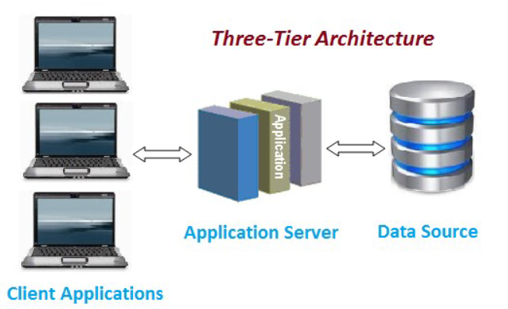

Figure 4: Three Tier Architecture

## **System Context**

The term system context alludes to the climate of our framework. A framework to be grown never remains all alone however is associated with its current circumstance. In the model above you see a model for the framework setting of a product introduced on a TV input. It supports on any operating system in any browser. Our website is made in such a way that it can fit on any system, it has responsive design. It means it can support on any types of platforms such as mobile phone, table etc.

Figure 5:System Context

## **User Interface/ Interaction Design**

The site can be gotten to utilizing various devices through ordinarily utilized browsers. At first, the User/Customer will be taken to home page which gives a short description about the restaurant. From their User can explore to various pages, for example, login page, Menu page, contact page, table booking page and so on User can likewise explore to home page from any of these pages.

### **Prototype**

Prototyping is a trial interaction where configuration groups carry out thoughts into substantial structures from paper to advance. Groups construct models of shifting levels of constancy to catch plan ideas and test on Users. The screenshots of the prototype of the Savoy Grill Restaurant website are as follows;

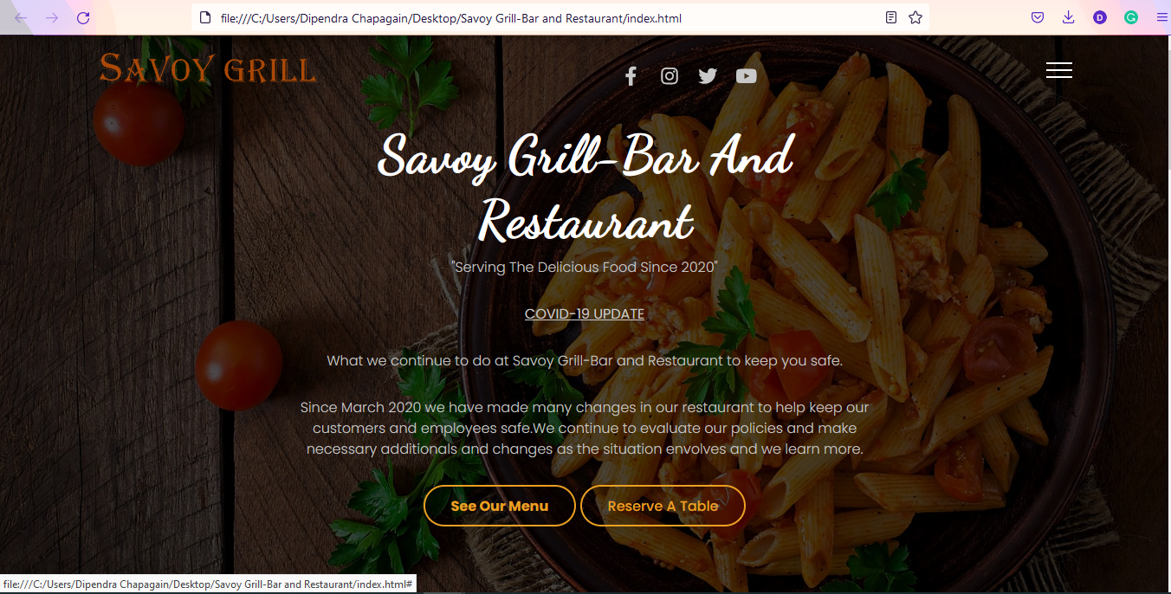

Figure 6:Prototype Homepage

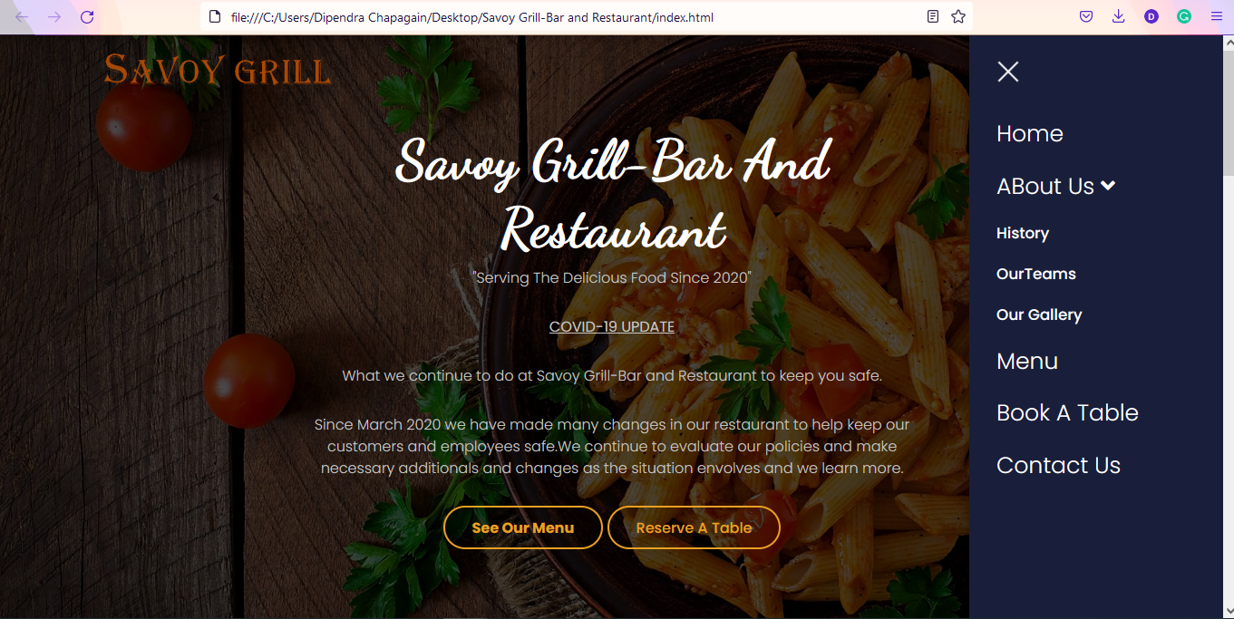

Figure 7:Prototype Navigational Menus

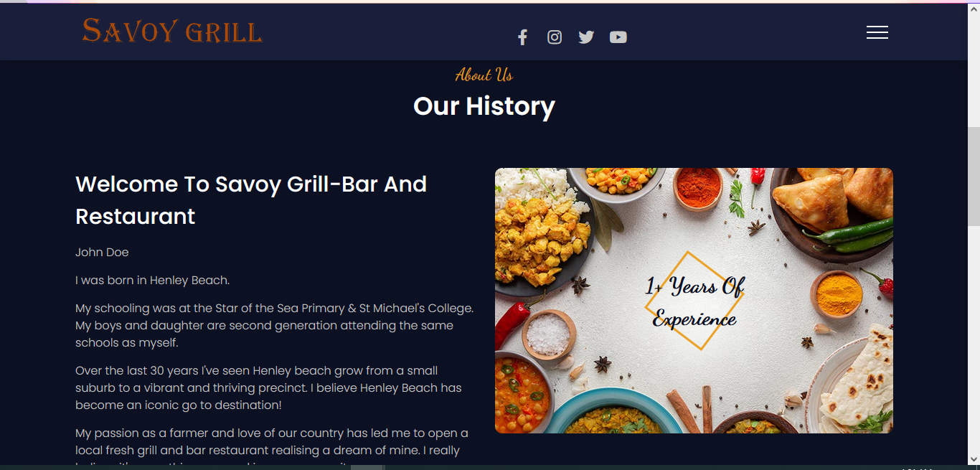

Figure 8:Prototype About Us Section

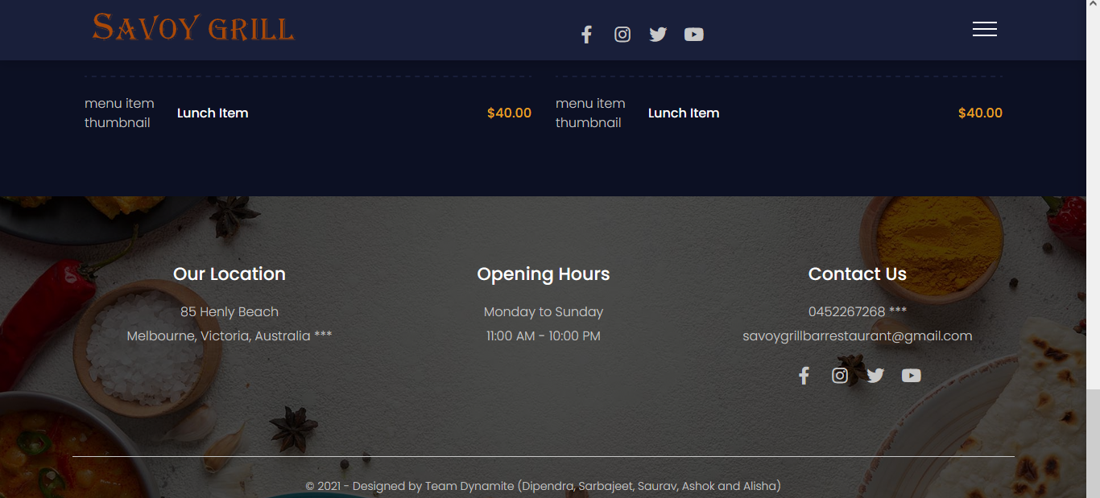

Figure 9:Prototype Footer

### **Use case diagram**

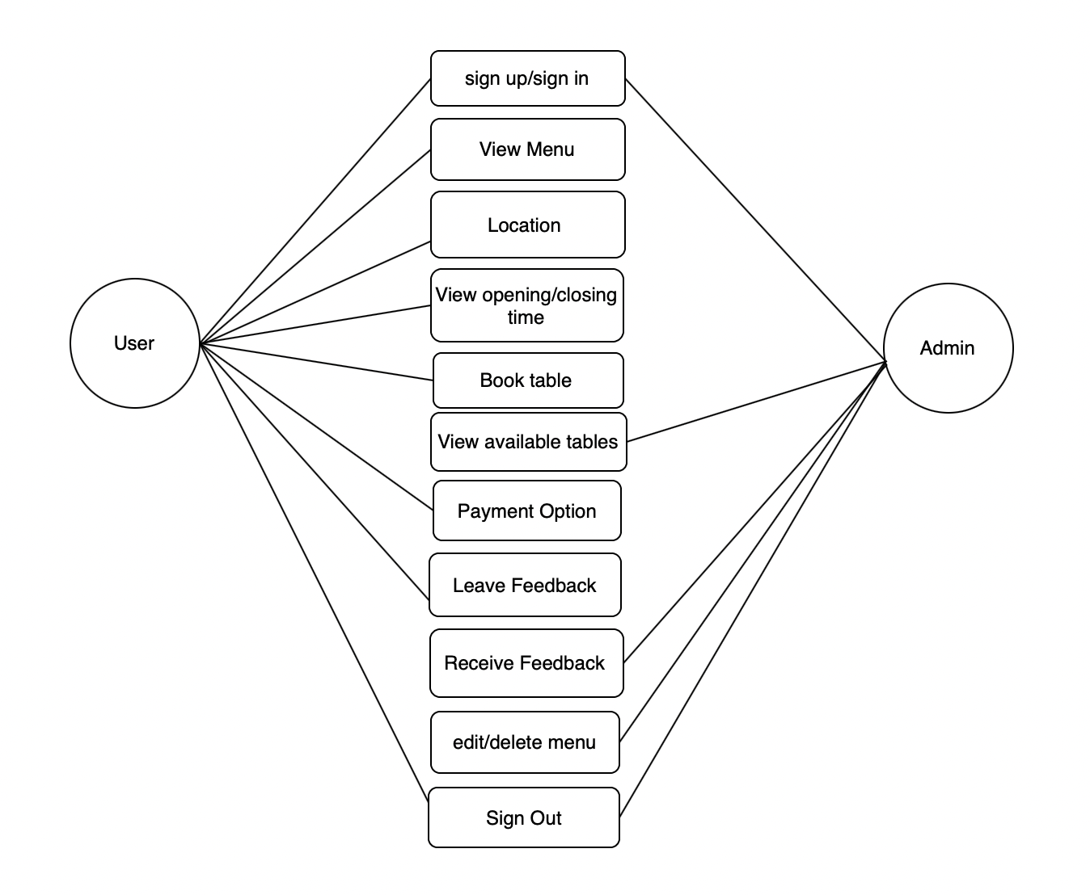

Figure 10: Initial Use Case Diagram

## **Data model and software design**

The Entity Relationship information model will be utilized to build the data set, which will be created utilizing the MySQL information base administration framework. There will be three phases of standardization in the information base that is created. There will be a connection between the elements, and each will have its own arrangement of qualities.

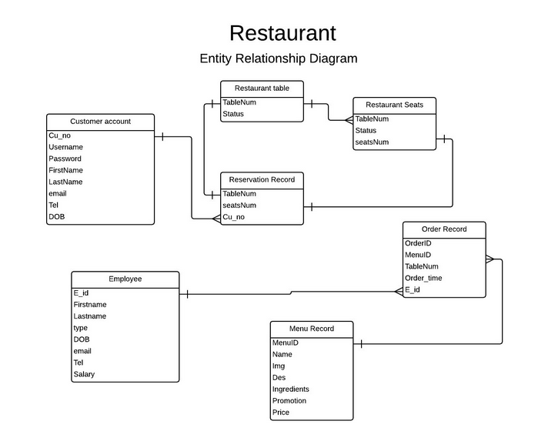

Figure 11:ER Diagram

## **Assumptions**

The following are the assumptions that were made when developing the project:

* The user will need to use any browser to website of the restaurant.
* A user will need to login in to book a table.
* All the users, information will be kept safe by the restaurant and can be changed if needed.

## **External Dependencies**

Using external dependencies made the development team to invest more time in application logic, by using out of the box solutions.

* Back-end dependencies

Dependencies that take part in HTTP communication like PHP, JAVA, MYSQL

* Front-end dependencies

Dependencies that execute on user's environment like HTML, CSS, JavaScript and User Interface.